C++ Project

Group 19

Stickman-Fight

Team members:

Poorneswar Reddy Chaganti IMT2020545

Shaurya Agrawal IMT2020539

Chaithanya Reddy Challapalli IMT2020054

Hasanabbas Momin IMT2020066

Ashish Gatreddy IMT2020073

Abstract:

Our team has created the game Stickman-Fight with all basic elements such as character (hero as well as enemy), scoreboard, movement of objects, animation, collisions, music etc using concepts of OOP taught in this course. The game starts with the main menu screen from which one can navigate to the game or Leaderboard screen. All 3 screen has different background music to them.

The game starts with a hero (the Hulk) in middle and enemy popping and running from both ends towards the hero. The goal is the kill the enemy before it reaches too close to the hero in which case the hero dies and the game ends.

Github link: https://github.com/Hasanabbas-Momin/Stickman-Fight

Instructions to run the game:

1. SDL installation additional linux command:

* sudo apt-get install libsdl2-dev libsdl2-image-dev libsdl2-ttf-dev libsdl2-mixer-dev #(for image, font and music)

1. Commands to run the game:

* make
* ./Stickman-Fight

Screenshots:

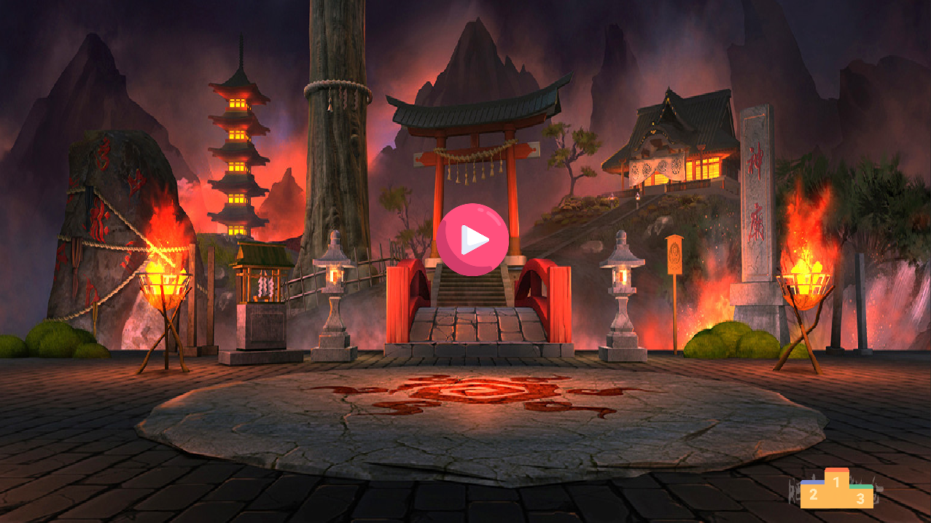

Controls of the game:

By default, the hero is not attacking when we start the game.

To start the attack by hero, press the spacebar.

Now the hero would continue to attack for some time.

There is a time limit for the hero to attack. Once the hero crosses the time limit it won't be able to attack for a certain small time.

After that, it can attack.

We could pause the attack of the hero also by pressing the space bar again to save some time before going into the time limit zone.

There are three types of attacks the hero can do :

The controls for changing the attacks are:

Q, W, E

As enemies are coming from multiple directions, we can change the direction of the hero.

The controls for changing direction are :

A, D

We can use escape button from both leader board as well while playing game to go to the main screen.